Kubota Dealer Analytics (KDA): This program allows you to manually export your Trial Balance reports directly to Kubota. You can also use it to review the Trial Balances you have already exported. NOTE: This program is only available to U.S. Kubota dealers.
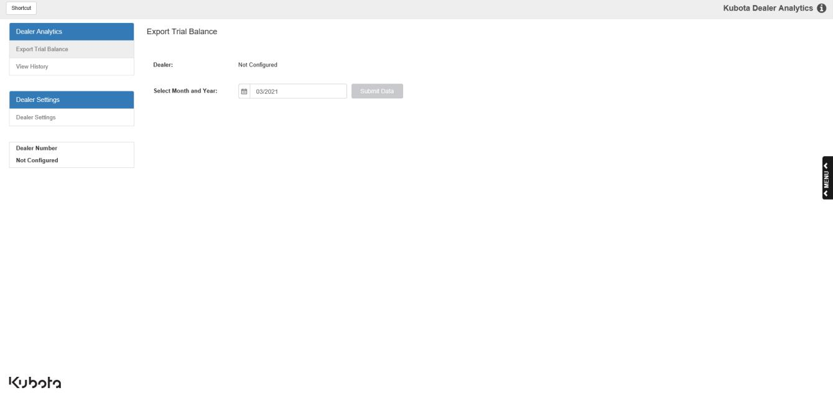

When you first open the program, you will see the screen pictured above. Notice that the Dealer Number reads “Not Configured”; you will need to set the program up before you can start sending your Trial Balances to Kubota.

Dealer Settings: Click the Dealer Settings tab to set up the program:
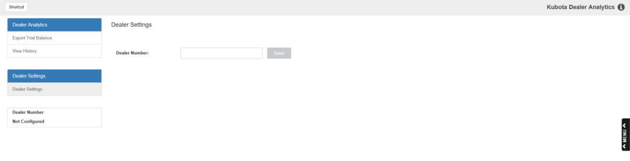

Dealer Number: Enter your Kubota Dealer Number in this field and click Save to store the number. This will allow you to begin sending your Trial Balances to Kubota. Once you save your number, the Dealer Number box on the left side of the screen will show the number to let you know it has been successfully saved.
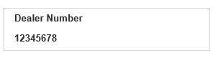

Export Trial Balance: You can now return to the starting screen by clicking the Export Trial Balance tab to begin sending your reports.
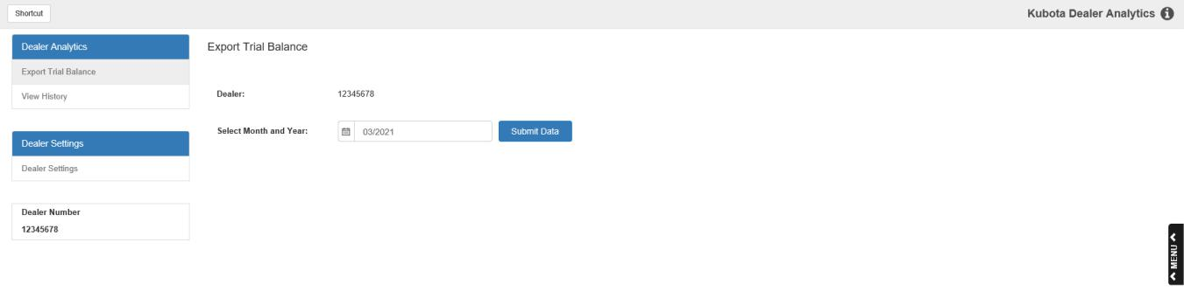

Dealer: This field now shows your saved dealer number.

Select Month and Year: Select the month/year of the Trial Balance you want to submit to Kubota. The field defaults to the last Trial Balance run, which if you are correctly performing your G/L Month End processes will belong to the month before the current month (for example, if it is currently April, then the last TB available will be from March). NOTE: Your Trial Balance must be in balance in order for you to submit it to Kubota—you will receive an error message if you try to submit an out-of-balance report.

Submit Data: Click this button to submit the Trial Balance from the selected month to Kubota. You will receive a success message if the submission is successful, or an error message if something has gone wrong and the report was not submitted.

View History: After you have successfully submitted your Trial Balance, the submission will be recorded in the View History tab. Click on the tab to view a list of all your prior Trial Balance submissions to Kubota:
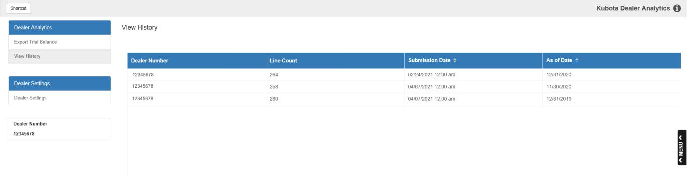

For each submission, the screen shows:

- The number of lines/account entries on the Trial Balance

- The date and time of the submission

- The date of the Trial Balance itself (when it was run as part of a Month End)

